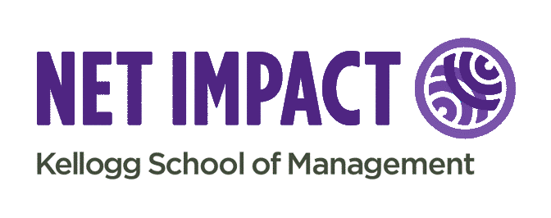
My Impact. Our Impact.
Make Your Action Plan - Part I: Discovery

Goal Setting
- What is your “Why?”

- What outcome do you want to achieve on as an individual and as a collective?

- What personal characteristics and skills would you need to focus on or achieve that outcome?

- Who else is doing similar work and what is their value proposition?

Discover Opportunities
My Impact | Our Impact
- Take a course  - Attend a conference  - Participate in a competition  - Assist with or start a new venture  - Conduct field or market research  - Get to know a professor  - Chat with an alum  - Get an internship  - Join a club  - Attend a club event  - Read the news  - Read a book  - Establish an accountability group  - Volunteer  - Get involved with a non-profit board | - Get involved with planning a conference or event  - Assist with or start a new venture  - Plan a club event  - Establish an accountability group  - Volunteer  - Consult a local business  - Sign a petition

Save the Date for Part II: Map the Course
Commit to a plan, set measurable goals and milestones, form a council
Tentatively scheduled: Feb 21st at 12:15pm CT (Register for updates: http://cglink.me/r884123)

